Paul Collado
CSC-208-60
Sept 23, 2010

ColladoCh02Page92

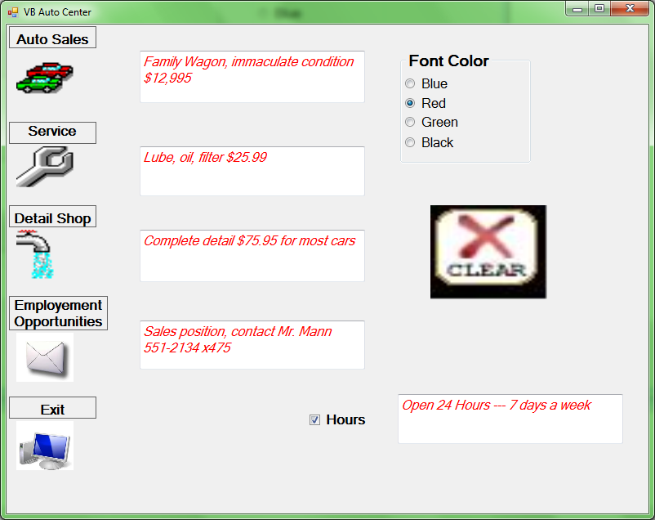

Public Class frmColladoCh02Page92

Private Sub btnAutoSales_Click(ByVal sender As System.Object, ByVal e As System.EventArgs)
'Display Auto Sales
Me.txtAuto.Text = "Family wagon, immaculate condition $12,995"

End Sub

Private Sub btnService_Click(ByVal sender As System.Object, ByVal e As System.EventArgs)
'Display Service Center
Me.txtService.Text = "Lube, oil, filter $25.99"

End Sub

Private Sub btnShop_Click(ByVal sender As System.Object, ByVal e As System.EventArgs)
'Display Detail Shop
Me.txtShop.Text = "Complete detail $79.95 for most cars"

End Sub

Private Sub btnEmployment_Click(ByVal sender As System.Object, ByVal e As System.EventArgs)
'Display Employment Opportunities
Me.txtEmployment.Text = "Sales position, contact Mr Mann 551-2134 x475"
End Sub

Private Sub btnExit_Click(ByVal sender As System.Object, ByVal e As System.EventArgs)
'Closes program
Me.Close()

End Sub

Private Sub frmColladoCh01Page58_Load(ByVal sender As System.Object, ByVal e As System.EventArgs) Handles MyBase.Load

End Sub

Private Sub txtAuto_TextChanged(ByVal sender As System.Object, ByVal e As System.EventArgs) Handles txtAuto.TextChanged

End Sub

Private Sub RadioButton1_CheckedChanged(ByVal sender As System.Object, ByVal e As System.EventArgs) Handles RadBtnblue.CheckedChanged
Me.txtAuto.ForeColor = Color.Blue
Me.txtService.ForeColor = Color.Blue
Me.txtShop.ForeColor = Color.Blue
Me.txtEmployment.ForeColor = Color.Blue
Me.TxtHours.ForeColor = Color.Blue
End Sub

Private Sub PictureBox1_Click(ByVal sender As System.Object, ByVal e As System.EventArgs) Handles PicCar.Click
Me.txtAuto.Text = "Family Wagon, immaculate condition $12,995"

End Sub

Private Sub PictureBox2_Click(ByVal sender As System.Object, ByVal e As System.EventArgs) Handles PicWrench.Click
Me.txtService.Text = "Lube, oil, filter $25.99"

End Sub

Private Sub PictureBox3_Click(ByVal sender As System.Object, ByVal e As System.EventArgs) Handles PicWater.Click
Me.txtShop.Text = "Complete detail $75.95 for most cars"
End Sub

Private Sub PictureBox4_Click(ByVal sender As System.Object, ByVal e As System.EventArgs) Handles PicMail.Click
Me.txtEmployment.Text = "Sales position, contact Mr. Mann" + vbNewLine + "551-2134 x475"

End Sub

Private Sub RadBtnRed_CheckedChanged(ByVal sender As System.Object, ByVal e As System.EventArgs) Handles RadBtnRed.CheckedChanged
Me.txtAuto.ForeColor = Color.Red
Me.txtService.ForeColor = Color.Red
Me.txtShop.ForeColor = Color.Red
Me.txtEmployment.ForeColor = Color.Red
Me.TxtHours.ForeColor = Color.Red
End Sub

Private Sub RadBtnGreen_CheckedChanged(ByVal sender As System.Object, ByVal e As System.EventArgs) Handles RadBtnGreen.CheckedChanged
Me.txtAuto.ForeColor = Color.Green
Me.txtService.ForeColor = Color.Green
Me.txtShop.ForeColor = Color.Green
Me.txtEmployment.ForeColor = Color.Green
Me.TxtHours.ForeColor = Color.Green
End Sub

Private Sub RadBtnBlack_CheckedChanged(ByVal sender As System.Object, ByVal e As System.EventArgs) Handles RadBtnBlack.CheckedChanged
Me.txtAuto.ForeColor = Color.Black
Me.txtService.ForeColor = Color.Black
Me.txtShop.ForeColor = Color.Black
Me.txtEmployment.ForeColor = Color.Black
Me.TxtHours.ForeColor = Color.Black
End Sub

Private Sub TextBox1_TextChanged(ByVal sender As System.Object, ByVal e As System.EventArgs) Handles TxtHours.TextChanged

End Sub

Private Sub ChkHours_CheckedChanged(ByVal sender As System.Object, ByVal e As System.EventArgs) Handles ChkHours.CheckedChanged
If Me.ChkHours.Checked Then
Me.TxtHours.Text = "Open 24 Hours --- 7 days a week"
End If
End Sub

Private Sub PictureBox5_Click(ByVal sender As System.Object, ByVal e As System.EventArgs) Handles PicExit.Click
Me.Close()
End Sub

Private Sub PicClear_Click(ByVal sender As System.Object, ByVal e As System.EventArgs) Handles PicClear.Click
Me.ChkHours.Checked = False
Me.TxtHours.Clear()
Me.txtAuto.Clear()
Me.txtService.Clear()
Me.txtShop.Clear()
Me.txtEmployment.Clear()
Me.RadBtnblue.Checked = False
Me.RadBtnRed.Checked = False
Me.RadBtnGreen.Checked = False
Me.RadBtnBlack.Checked = False
End Sub

Private Sub Label2_Click(ByVal sender As System.Object, ByVal e As System.EventArgs) Handles Label2.Click

End Sub
End Class

